MASSACHUSETTS EMERGENCY MANAGEMENT AGENCY
SITUATIONAL AWARENESS STATEMENT
January 9, 2018
3:00 PM
Potential Heavy Rain and Flooding Friday/Saturday
Situation
From the National Weather Service:

The NWS is monitoring the potential for flooding of urban areas, and possibly rivers and small streams, Friday into Saturday from the combination of heavy rain (2-4 inches) and melting snow.

The NWS is most confident in at least minor flooding of urban and poor drainage areas, and less so for flooding of rivers and streams. A graphic showing potential rainfall is below.

What:
• Heavy Rain (potentially as much as 2 to 4 inches)
• Potential Flooding (rivers/streams and urban/poor drainage areas)
Where:
• All of southern New England
When:
• Friday into Saturday, although river flooding (if it occurs) could last through the weekend.
Uncertainty

Since the storm is still a few days away, there is a lot of uncertainty. Here are the questions that the NWS will address over the next day or two:
• Where does the heaviest rain (more than 3 inches) fall? While this is currently expected on Cape Cod and the Islands, this may change over the next few days.
• How warm does it get, and for how long? Temperatures will rise into the 40s and 50s Friday, but how long they remain that warm will affect the amount of snow melt and runoff into rivers, streams, and catch basins.
• How much will rivers and streams flood? While the NWS is more confident in flooding of urban and poor drainage areas, the amount of combined rain and melting snow, and possibly river ice breakup, will determine the extent of river and small stream flooding.
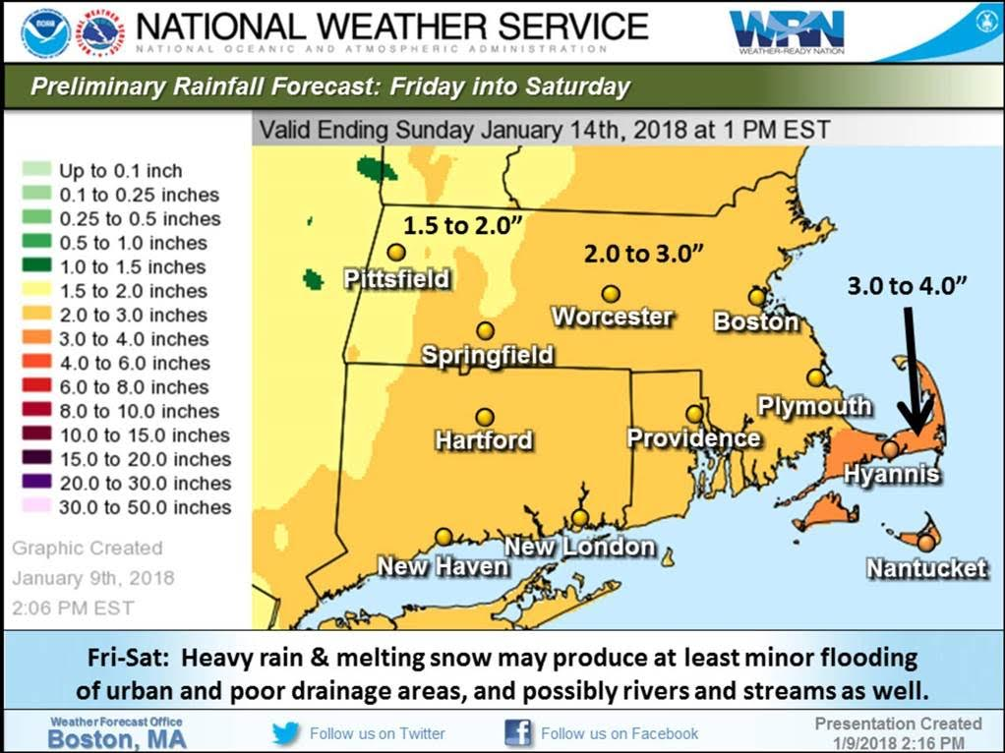

SEOC Activation Level
The State Emergency Operations Center (SEOC) is operating at Level 1 (Steady State Monitoring). MEMA will continue to monitor the forecast and will disseminate additional Situational Awareness Statements as necessary.

Preparedness and Safety Information
- Flood Safety and Preparedness Tips are available at:
https://www.mass.gov/service-details/flood-safety-tips

Stay Informed:
Utilize Massachusetts Alerts to receive emergency notifications and information from the Massachusetts Emergency Management Agency and the National Weather Service. Massachusetts Alerts is a free app that is available for Android and iPhones. To learn more about Massachusetts Alerts, and for information on how to download the free app onto your smartphone, visit: www.mass.gov/mema/mobileapp.

Utilize MEMA’s real-time power outage viewer to stay informed about current power outages in your community and region, and across the state, including information from utility companies about restoration times: http://mema.mapsonline.net/public.html
Utilize MEMA’s live weather radar and forecasting tools, including the live snowfall forecast map: http://memamaps.maps.arcgis.com/apps/MapSeries/index.html?appid=0da6e4d888b74317b52b7a5064aa3dc2
Follow MEMA on Facebook (@MassachusettsEMA), Twitter (@MassEMA), and Nextdoor (www.Nextdoor.com)
Online Resources:
For additional information and resources, visit:
Massachusetts Emergency Management Agency at www.mass.gov/mema
MEMA's Facebook page: http://www.facebook.com/MassachusettsEMA
MEMA Twitter: @MassEMA
Federal Emergency Management Agency at www.fema.gov
National Weather Service/Taunton at www.weather.gov/boston
National Weather Service/Albany, NY at www.weather.gov/albany
National Weather Service Weather Prediction Center: http://www.wpc.ncep.noaa.gov
National Weather Service Storm Prediction Center: http://www.spc.noaa.gov/
National Weather Service Northeast River Forecast Center: http://www.weather.gov/nerfc/
Mass211 at www.mass211.org

